|  |  |  |  |
| --- | --- | --- | --- |
| Description: pact jpg1 | **Mathematics Essential**  **Test 4, 2015**  **Topics - Graphs** | | 40  = % |
| **Total Time:** | ***45*** *minutes* |  | |
| **Total Reading:** | *5**minutes* |
| **Total Working:** | *40**minutes* |
| **Weighting:** | *5% of the year.* |
| **Equipment Allowed:** | *Calculator* |
| ***You must include all working out to receive full marks*** | | | |
| **CALCULATOR ASSUMED** | | | |

1. **(5 marks:1, 1, 1, 2)**

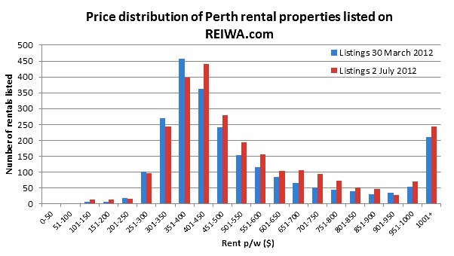

* 1. From the above graph what is the lowest rent per week?________________
  2. What is the highest rent per week?_________________________________
  3. Which rent bracket has the most number of rentals?____________________
  4. Explain why the $1001 + rent p/w column has a sharp increase compared to the previous columns.___________________________________________

_______________________________________________________________

_______________________________________________________________

1. **(8 marks:1, 1, 2, 2, 2)**

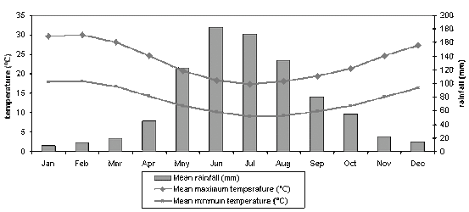

* 1. What is the mean maximum temperature in September?__________________
  2. Which month has the coldest mean minimum temperature**?_______________**
  3. What is the difference between the mean maximum and mean minimum

temperatures in May?_____________________________________________

* 1. How much more rain falls in June than December?______________________
  2. Describe the annual rainfall pattern?_________________________________

_____________________________________________________________________________________________________________________________________________________________________________________________

1. **(10 marks;7,1,1,1)**

56 children were asked which of the following hobbies they prefer. Their results are recorded in the table below.

|  |  |  |  |  |
| --- | --- | --- | --- | --- |
|  | Computer games | Watch Films | Read | Total |
| Girls | 5 |  |  | 22 |
| Boys |  | 11 |  |  |
| Total | 24 |  | 10 |  |

1. Complete the missing values
2. How many boys prefer computer games?
3. What percentage of children watched films?
4. What percentage of girls read books?
5. **(6 marks)**

The following data set shows the temperatures over 1 day.

|  |  |  |  |  |  |  |  |  |  |
| --- | --- | --- | --- | --- | --- | --- | --- | --- | --- |
| **Time** | **Noon** | **3pm** | **6pm** | **9pm** | **Midnight** | **3am** | **6am** | **9am** | **noon** |
| **Temperature** | **30C** | **33C** | **30C** | **29C** | **25C** | **23C** | **22C** | **28C** | **32C** |

Draw an appropriate graph for this data

|  |  |  |  |  |  |  |  |  |  |  |  |  |  |  |  |  |  |  |  |
| --- | --- | --- | --- | --- | --- | --- | --- | --- | --- | --- | --- | --- | --- | --- | --- | --- | --- | --- | --- |
|  |  |  |  |  |  |  |  |  |  |  |  |  |  |  |  |  |  |  |  |
|  |  |  |  |  |  |  |  |  |  |  |  |  |  |  |  |  |  |  |  |
|  |  |  |  |  |  |  |  |  |  |  |  |  |  |  |  |  |  |  |  |
|  |  |  |  |  |  |  |  |  |  |  |  |  |  |  |  |  |  |  |  |
|  |  |  |  |  |  |  |  |  |  |  |  |  |  |  |  |  |  |  |  |
|  |  |  |  |  |  |  |  |  |  |  |  |  |  |  |  |  |  |  |  |
|  |  |  |  |  |  |  |  |  |  |  |  |  |  |  |  |  |  |  |  |
|  |  |  |  |  |  |  |  |  |  |  |  |  |  |  |  |  |  |  |  |
|  |  |  |  |  |  |  |  |  |  |  |  |  |  |  |  |  |  |  |  |
|  |  |  |  |  |  |  |  |  |  |  |  |  |  |  |  |  |  |  |  |
|  |  |  |  |  |  |  |  |  |  |  |  |  |  |  |  |  |  |  |  |
|  |  |  |  |  |  |  |  |  |  |  |  |  |  |  |  |  |  |  |  |
|  |  |  |  |  |  |  |  |  |  |  |  |  |  |  |  |  |  |  |  |
|  |  |  |  |  |  |  |  |  |  |  |  |  |  |  |  |  |  |  |  |
|  |  |  |  |  |  |  |  |  |  |  |  |  |  |  |  |  |  |  |  |
|  |  |  |  |  |  |  |  |  |  |  |  |  |  |  |  |  |  |  |  |
|  |  |  |  |  |  |  |  |  |  |  |  |  |  |  |  |  |  |  |  |
|  |  |  |  |  |  |  |  |  |  |  |  |  |  |  |  |  |  |  |  |
|  |  |  |  |  |  |  |  |  |  |  |  |  |  |  |  |  |  |  |  |
|  |  |  |  |  |  |  |  |  |  |  |  |  |  |  |  |  |  |  |  |

1. **(4 marks)**

Police recorded the average number of people caught drink driving on the same section of road on different nights of week.

|  |  |  |  |  |  |  |  |
| --- | --- | --- | --- | --- | --- | --- | --- |
| Monday | 5 | Tuesday | 6 | Wednesday | 4 | Thursday | 10 |
| Friday | 12 | Saturday | 17 | Sunday | 8 |  |  |

Represent the above information as a pictograph. Use a bottle to represent two people.

1. **(4 marks: 1, 1, 2)**

This stem and leaf plot shows the scores of students in a class.



1. How many students took the test?
2. How many students got a score of 60?
3. How many students got a score less than 50?
4. **(3 marks)**

Construct a stem and leaf plot to show the following.

